# Adding Guest Users to the Queen Margaret Organization

To add guest users to the QMC organization for applications such as Microsoft Teams access, do the following.

## Adding Members

Navigate to the Office 365 Admin Centre

In the panel on the far left, go into the “Admin Centers” drop down, and select “Azure Active Directory”. This is highlighted in red in the image below.

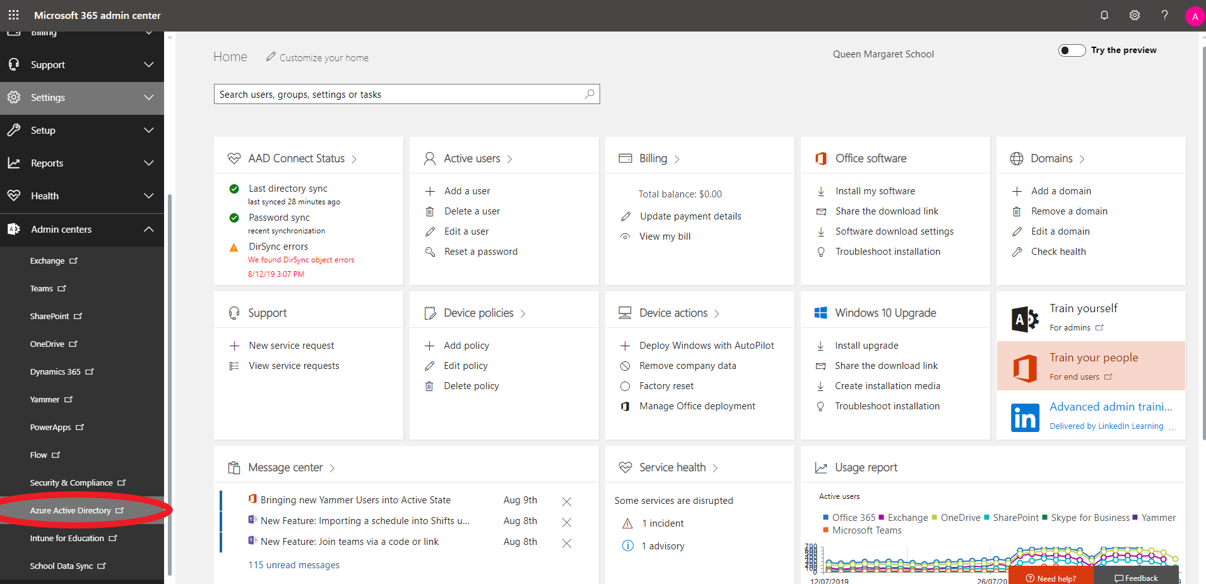

The following steps refer to the below image.

1. Once in Azure Active Directory, click on “Users” on the far left.
2. Click “New Guest User” in the top bar in the middle of the page
3. 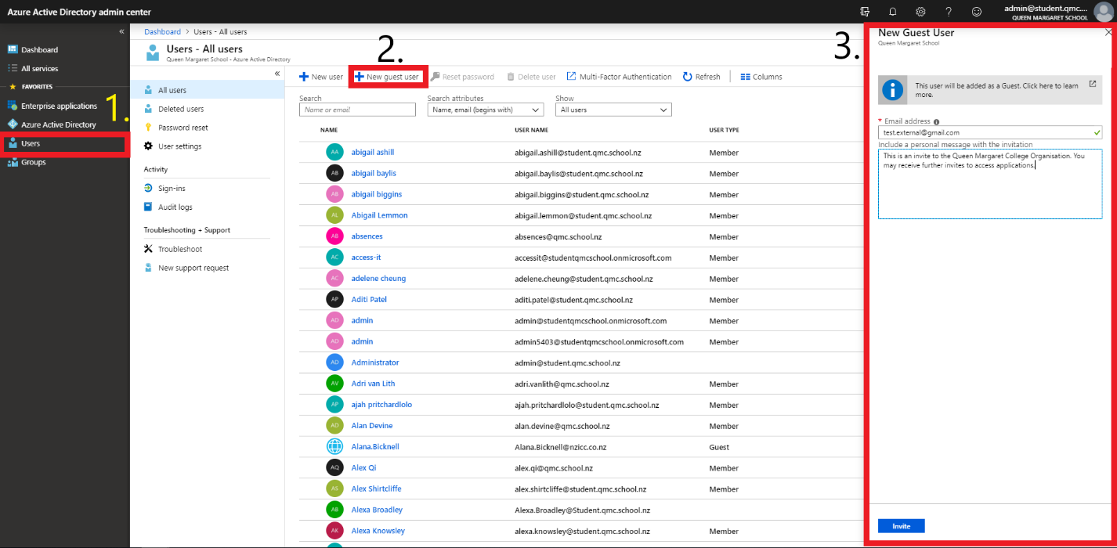Input their email address and then a message if you desire, but I would advise to as they may not know why they are getting the email or what to do with it. This would be a good place to outline what is happening and what they should do.

## Creating Groups

Go back to the dashboard

Under the “Quick Tasks” section on the dashboard, there is an option to “Add a Group”. Click on this to create a new group for your guests. The may also be a short cut on the left panel, under the Favorites. These are both highlighted in red.

Either click “Add new group” or click on Groups on the left panel and then “New Group”, which is found in the same spot in the interface as the option to add a guest user to AAD, except this is under the “Groups” option. This is where a group for the guest users will be created. They are both highlighted red below.

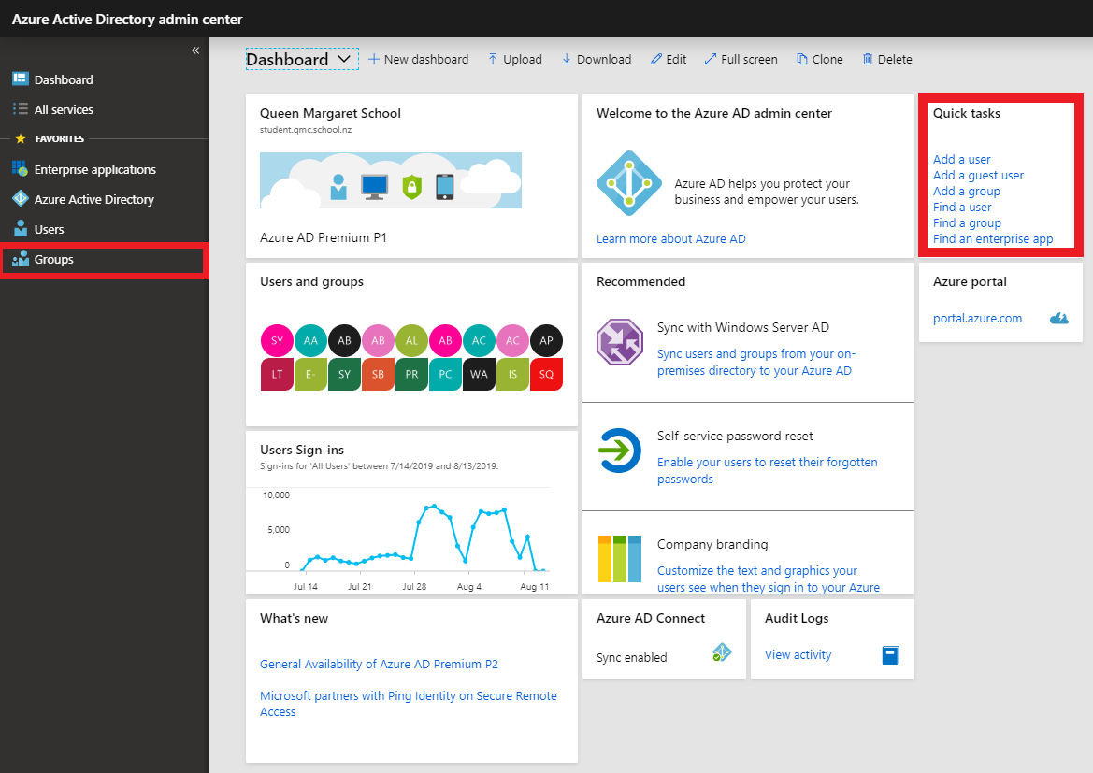

Set up the group as intended, such as the Name, Description and membership type. The Group Type can be kept as security.

I kept the membership type as “Assigned”, which lets you add specific users to be members of the group and to have unique permissions. Dynamic user and dynamic device allow dynamic rules to automatically add or remove members / devices.

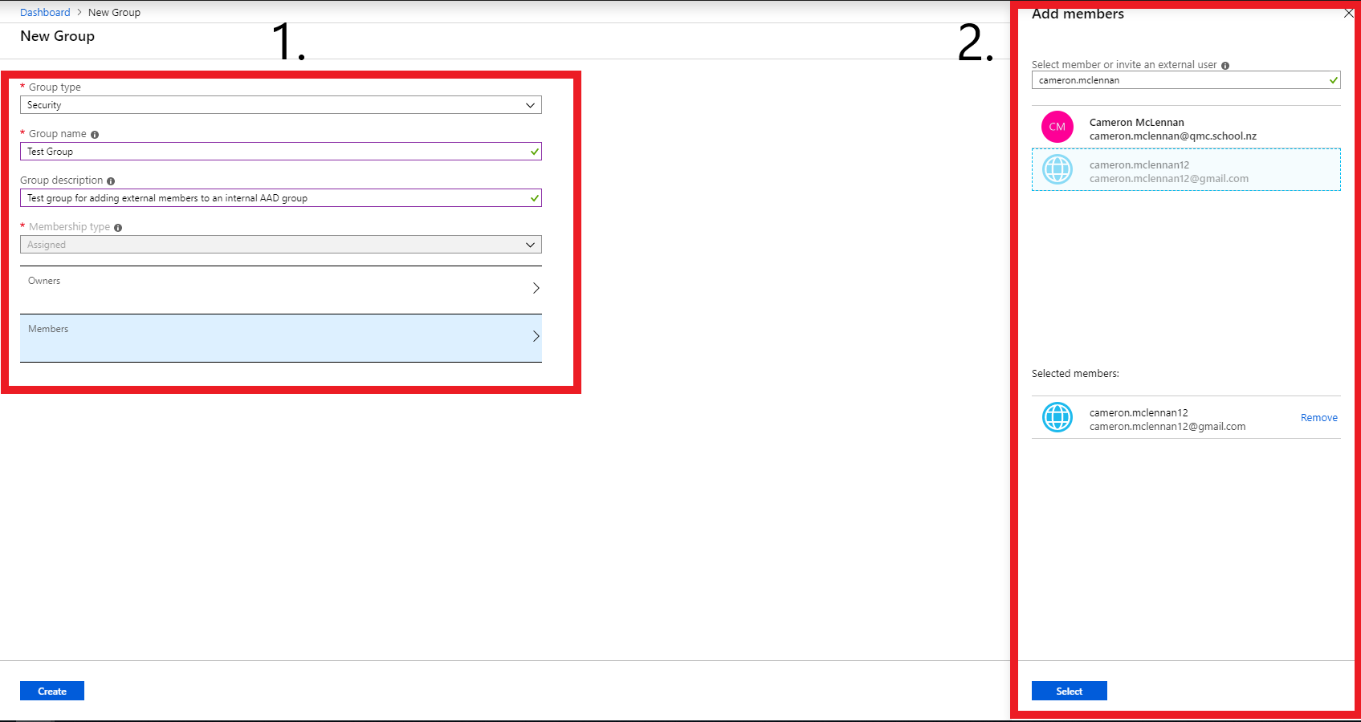You can now add owners of the group, and the members of the group. You can edit the owners / members later on. This was all section 1 of the below screenshot. Section 2 is what appears when you click on the “Owners” or “Members”. Section 2 has a text box up the top where you type in the email address(es) of those you wish to add to this new group, provided that they have been added to AAD as a guest. If they have not been yet, this is okay as adding members to a group can be done quite easily later on. Back on the main dashboard you can click “Groups” if the shortcut is on the left, or under the “Quick Tasks” you can click “find a group”. Once you have clicked on either link you should see a search option to search for the group. From here, you will be able to go in and add users to the group under the “members” tab.

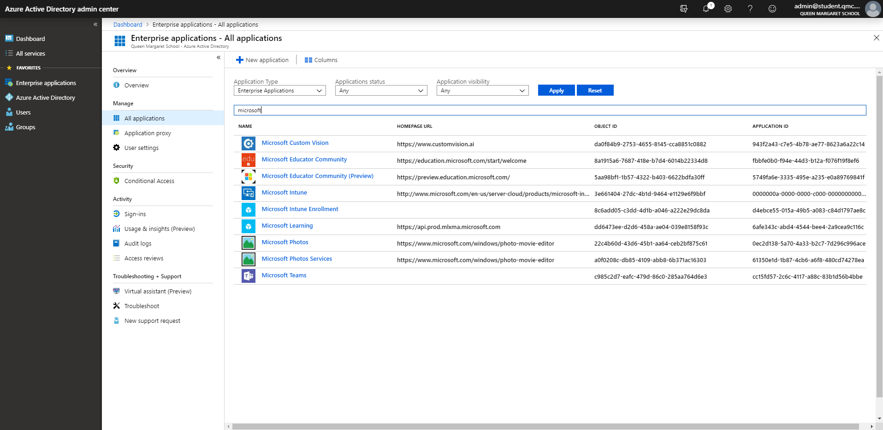Once the group is created, you will need to assign applications. Head to “Enterprise Applications” and then search for the application you wish to add. In this case, it will be Teams.

You will need to now need to begin the adding process. Under the “users and groups” tab in the application panel to the left you can add a user, or group. Search for the group that you made or specific user that you wish to add permission to access the application.

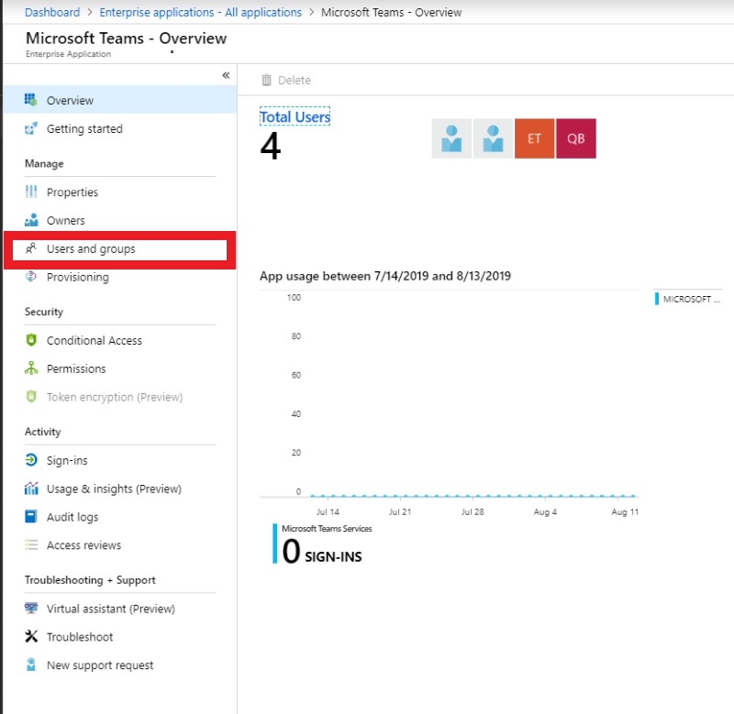

The external guest users should get an email invite to start to use the application, in this case they would get a Microsoft Teams invite. In this case, these users can now be added as a guest to any Team in Microsoft teams, and they get added as any normal user would get added.